Self-care

1. Know the facts that will help you to be in control and know what you can do. There is a lot of information about the coronavirus; you probably come across facts, assumptions or speculation, false reports and stories on social media, which, in turn, may amplify your anxiety. It can be very difficult to know whether or not some information is true. Access reliable and up-to-date information through the government and NHS websites.


2. Find things that help you feel calm. Be present and try relaxation and breathing techniques. Learn to breathe by trying mindfulness or relaxation apps, practicing deep breathing, or playing music. You also can make a self-care box or a happy box. A self-care box is something to get out on days when you feel low/sad/stressed/anxious etc. The aim is to pick objects for the box that will lift your mood. What goes in the box is individual to you. Treat yourself; this might be to a relaxing bath, a run, a favourite TV programme or a bar of chocolate!
This Photo by Unknown Author is licensed under CC BY-SA

3. Reflect: Don’t ignore your thoughts and feelings. Some of us may have a habit of escaping the uncomfortable feelings that the current crises evoke in us, but those feelings need to be processed. So, take some time to quietly reflect internally, focusing on sensations, images, feelings and thoughts; recognise that you have emotions, name them and control them enough to enable yourself to choose how you respond. You may write down your worries and anxieties; or keep a journal. It is important that you don’t ignore your anxieties, but also don’t allow your worries to take over you, so you don’t feel swept along by your thoughts and feeling of anxiety.

- You can set aside a specific worry time of 10–15 minutes each day. Spend this time thinking about your worries: you can write them down, draw, or make notes in a journal. It doesn’t matter how you express your fears as long as you acknowledge that you are feeling this way, and then remember to put your worries away. You may also try some calming breathing.
- Or you might try to approach your feelings as if you were a curious scientist — for example, notice “I am having thoughts about catching COVID-19!”. After noticing and bringing this to your awareness, do some exercises that allow you to move out of your head and back into your body (do some breathing, pushing your feet into the ground, walk around, clap and rub your hands together), and remain engaged in the physicality of those exercises.


4. Ensure you have access to natural light If your exposure to natural light is limited, it may result in a drop in the production of melatonin and serotonin, which are essential for our mental health and well-being. Plan daily exercise during the daytime, and sit in the garden or next to the window to access daylight. Eat foods that help boost melatonin such as walnuts, cherries, milk or bananas. Salmon, poultry, eggs, soy products, nuts, milk and spinach are among the foods that can help boost serotonin.
This Photo by Unknown Author is licensed under CC BY-ND

5.Look after your well-being by having a regular sleep pattern and getting enough sleep. It’s easy to develop unhealthy coping strategies. So, reduce your consumption of drinks that contain caffeine or alcohol. Make an effort to exercise; when you exercise, your body releases endorphins, dopamine and serotonin—hormones that are essential for your health. Also, make healthier food choices to strengthen your immune system and improve your well-being.

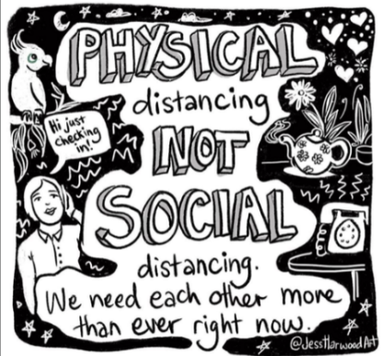
6. Don’t pressure yourself. The pressure to know the answers, to carry on with life as if had no impact on you; the pressure of smiling even though you may not feel like it; the pressure of having different values, making difficult decisions and feeling criticised; and the pressure to look as though you have it all together can all cause anxiety. Try to be kinder to yourself and acknowledge that you are doing your best under the circumstances you are in.

7. Keep in touch with family and friends. We are social animals, so we need and desire closeness with other people. Currently we are being asked to distance from others, so it’s important that we consider creative ways to connect in order that we don’t become isolated and feel lonely.

8. Reach out for support. Remember you are not alone; talk to someone and ask for help. It’s strength to reach out and ask for support, so speak to someone you trust—a friend, a family member or a helpline. You may want to make a list of people you know and identify those who are good at providing practical, psychological and moral support.

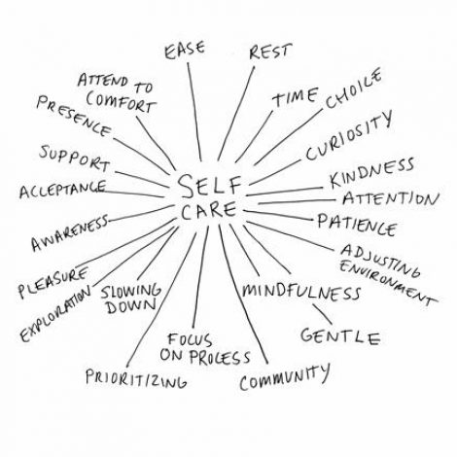
This Photo by Unknown Author is licensed under CC BY-SA-NC

The 30-3-30 approach

(taken from: http://learn.4mentalhealth.com/sites/default/files/courses/wb8/index.html#/id/5e7dd232485e8e466da2f36a)

The suggestions below are grouped into things that take about 30 seconds, things that you can do in about 3 minutes, and things that might take 30 minutes or longer. The 30 second ones are quick fix ‘emergency’ actions you can do if you suddenly feel panicky, scared or unable to cope.

30 seconds | 3 minutes | 30 minutes
Take a few slow deep breaths. Breathe in, count to 3, breathe out, count to 3. | Phone a loved one or friend for a quick chat. Leave a message if they don’t answer. | Pamper yourself with a luxurious bath, and maybe have scented candles and soothing music.
Close your eyes, hold one hand in the other, squeeze gently and repeat ‘I can get through  this’. | Do a household task, like a quick bit of washing up, cleaning the bathroom mirror or making a bed. | Do ‘proper sort-out’ of a cluttered kitchen cupboard, drawer, wardrobe or bookcase. Feel the satisfaction of  having done something!
Sit on a chair and focus on the sensation of the chair pressing onto your back and bottom. | Make a hot drink in a mug and sip it slowly, feeing the warmth of the mug in both hands. | Enjoy a TV or radio programme, either a recording of an old favourite or something new.
Take a few sips of cold water, focusing on the cooling feeling as you swallow it. Even better if very cold or if you can add ice. | Quick brain workout, such as 3 minutes doing a wordsearch, crossword, sudoku. Try the ‘Alphabet Game’ choose a category, then using the alphabet  in order, list as many as you can. | Do something ‘mindful’. This means just focusing on the one thing you are doing: such as bit of gardening, spending time on an indoor hobby, doing a jigsaw puzzle, listening to a  recorded book.
Look out of a window or doorway. What can you see and hear? Anything new or  unusual? | Listen to a favourite piece of music, something soothing or uplifting depending how you feel. | Prepare a tasty meal or snack, perhaps a new recipe, and eat it slowly, savouring every mouthful.
Pick up a special photo or object that evokes happy memories and focus on what it means to you. | Brush your teeth and brush or comb your hair. (even if you don’t really need to!) | Sing. At the top of your voice, sing all the songs you know, or just your favourites several times.
Learn a favourite, inspiring quote by heart, or keep a written version handy to read. | Write a worry list. Getting things down on paper can help stop them going around in your head.  Now tackle them one by one. | Go out for some fresh air, if it’s safe and allowed. If not, are there any indoor exercises, yoga or stretches  you can do?
Think of 2 things that are ‘Just about OK’. | Phone someone for a quick ‘hello’ | Phone a helpline. Ask the person who sent you this leaflet to recommend a couple of helplines if you can’t think of any yourself.

Online support/ helpline

- Campaign Against Living Miserably (CALM) – for men Call 0800 58 58 58 – 5pm to midnight every day Visit the webchat https://www.thecalmzone.net/help/webchat/
- Catalyst Drug and alcohol service https://www.catalystsupport.org.uk/
- Cruse Bereavement care Helpline: 0808 808 1677 Website: https://www.cruse.org.uk/
- Mind helpline provides information and signposting service. Open 9 am to 6 pm, Monday to Friday (except for bank holidays). Infoline: 0300 123 3393 Email: info@mind.org.uk Text: 86463Phone calls from UK landlines are charged at local rates.
- Mind Matters Surrey IAPT (Improving Access to Psychological Therapies) is a talking therapy service for adults (18+) registered with a GP in Surrey. They provide quick and easy access to talking therapies, https://www.mindmattersnhs.co.uk/
- Samaritan helpline - Whatever you're going through, samaritans will face it with you. Open 24 hours a day, 365 days a year. Call 116 123 for free https://www.samaritans.org/
- Surrey domestic abuse helpline 01483 776822 9am to 9pm, 7 days a week
- Papyrus HopeLine UK- free confidential helpline or online support for anyone having suicidal thoughts, or for anyone concern about young person at risk of harming themselves. Helpline:08000684141 (Monday-Friday 10.am-10pm.; Saturday-Sunday 2pm-5pm www.papyrus-uk.org/support/for-you
- The Mental Health Crisis Helpline is a telephone service offering support to adults of all ages in Surrey and North-East Hampshire who are experiencing a mental health crisis. Lines are open 24 hours, seven days a week. You don’t need to book an appointment and calls are free of charge. 0800 915 4644
- Education support Telephone support and counselling; Helpline: 0800056261
https://www.educationsupport.org.uk/helping-you/telephone-support-counselling

Information and other resources

- Action for Happiness is a movement of people committed to building a happier and more caring society. We want to see a fundamentally different way of life - where people care less about what they can get just for themselves and more about the happiness of others. https://www.actionforhappiness.org/about-us
- AnxietyUK – offers support, advice and information on a range of anxiety disorders https://www.anxietyuk.org.uk/get-help-now/anxietyinformation/
- Anxiety Alliance – helping and supporting those suffering from anxiety http://www.anxietyalliance.org.uk/
- Anxiety workbook with lots of activities and coping strategies - printable https://www.carlislehealthcare.co.uk/media/content/files/Coronavirus-Anxiety-Workbook.pdf
- Moodjuice- self-help booklet for people experiencing depression http://www.moodjuice.scot.nhs.uk/depression.asp
- COVID-19 vs. Your OCD Symptoms https://iocdf.org/covid19/covid-19-vs-your-ocd-symptoms
- Mind – support and information about various mental health issues http://www.mind.org.uk/information-support/types-of-mental-health-problems/anxiety-and-panic-attacks/about-anxiety/#.VfqDf7RqfTQ
- Royal College of Psychiatrists – leaflets and advice on various mental health issues.
- http://www.rcpsych.ac.uk/expertadvice/youthinfo/parentscarers/growingup/worriesandanxieties.aspx
- OCD Action –helpline for support and offers information on a range of obsessive behaviours.



